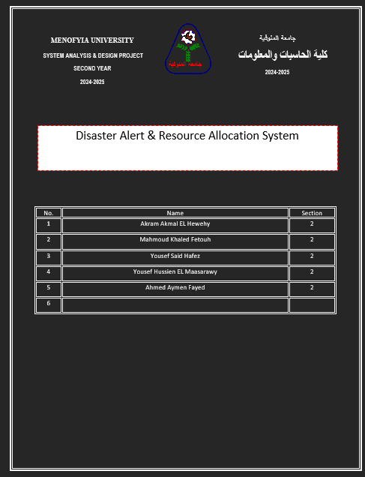

Project Name:
Disaster Alert & Resource Allocation System
Current Problem:
- Warnings about floods, fires, earthquakes and storms reach people late, or only through a few channels such as TV and word of mouth.
- Emergency teams, shelters, medical supplies, food and vehicles are assigned by phone calls and paper lists, so they are often sent to the wrong place or duplicated.
- There is no single live picture of which areas are hit hardest, what each shelter or depot holds, and which needs are still unmet.
- Records can be lost, and manual counting causes errors that cost time when every minute matters.
Description about project:
- The system is a web-based application that lets authorities publish disaster alerts by area and severity and deliver them to citizens by SMS, email and push notification.
- It keeps a live inventory of resources (ambulances, rescue teams, water, food, medicine, shelter beds) and suggests where to send them according to the severity and population of each affected zone.
- It gives decision makers a dashboard with maps, reports and statistics, which reduces response time, prevents duplicated or missed deliveries, and supports better decisions during and after an incident.

System Request
Project Sponsor | National / Local Civil Defense and Emergency Management Authority (Target Users: emergency operators, relief agencies, and citizens)
Business Need | The urgent need to warn people quickly and to send limited rescue and relief resources where they are needed most, in order to save lives and reduce damage.
Business Value | 1. Fast, multi-channel alerts that reach people in affected areas within minutes.  2. Real-time visibility of available resources and unmet needs.  3. Less waste and fewer duplicated deliveries through data-based allocation.  4. Better planning and accountability through reports and post-disaster
Special Issues or Constraints | 1. Strict project deadline, with a working version needed before the next disaster season.  2. The system must stay available during emergencies, including heavy load and weak networks.  3. Protection of citizens' personal data (phone numbers, locations) and strict access control, so only authorized staff can issue alerts.  4. Dependence on third-party services such as SMS gateways and weather or seismic data feeds.

Feasibility Analysis
Technical Feasibility:
- The user interface is built with HTML, CSS and JavaScript, with an interactive map library (such as Leaflet/OpenStreetMap) for affected zones and resource locations.
- Development tools such as Visual Studio Code, a backend framework and a database (for example Node.js with PostgreSQL) are free and widely available.
- The system runs online as a web application, with an SMS/email/push gateway API for sending alerts and a connection to weather or seismic data feeds.
- The website must be compatible with standard browsers and operating systems on Windows, Android and iOS, and must work on weak mobile connections.
Economic Feasibility:
- The benefits (lives protected, faster response, less wasted relief) are high and clearly outweigh the cost.
- The risks and potential losses are small and mostly limited to initial development time.
- Running costs are mainly cloud hosting and per-message alert fees.
- Development cost is low because most tools and frameworks are open-source or free.
Organizational Feasibility:
The assessment covers:
- Management prowess: the readiness of the civil defense management team and emergency coordinators to adopt and run the system, including clear authority for who may issue alerts.
- Resource sufficiency: the non-financial resources required, such as trained operators, a small technical support team, an operations room with internet access, agreements with mobile operators, and data-sharing agreements with weather and relief agencies.

Time Estimation
The project is planned at 90 days in total, split by the standard phase percentages.
Phase | Standard Percentage | Estimated Time (based on planning time)
Planning | 15% | 14 days
Analysis | 20% | 18 days
Design | 35% | 31 days
Implementation | 30% | 27 days

Cost-Benefit Analysis: Disaster Alert & Resource Allocation System
All figures are planning estimates, not quotes.
Category | Description | Estimated Cost | Estimated Value / Benefits
Software | In-house development, map and mobile-friendly web interface, tool licenses | $1,500 - $3,000 | One central system replaces phone calls and paper lists, reducing errors and delays
Hardware | Cloud server hosting, database and backup storage | $600 - $1,200 | High availability during emergencies and safe data backup
Alert Gateway | SMS, email and push notification services, weather/seismic data feeds | $400 - $900 annually | Warnings reach people in affected areas within minutes
Training | Onboarding for operators and relief staff, quick guide sessions | $200 - $500 | Correct use of the system and a confident response team
Maintenance | Annual updates, bug fixes, security patches and drills | $300 - $600 annually | Continuous stability, security and readiness

Summary
Total Estimated Costs (first year): $3,000 - $6,200
Total Estimated Annual Benefits/Savings: $8,000 - $15,000+ (less wasted relief supplies and faster response, not counting lives and property protected)
Payback Period: Within 1 year
Conclusion:
The Disaster Alert & Resource Allocation System is economically feasible, with clear savings in resources and time and a major gain in public safety.

